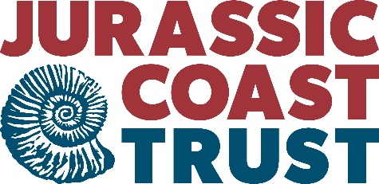
JOB DESCRIPTION
Jurassic Coast Protected Site Strategy Project Officer

Role Outline:
The Jurassic Coast Protected Site Strategy Project Officer is accountable to the Principal Officer World Heritage, the CEO and Jurassic Coast Trust’s Board of Trustees for all aspects of work programme delivery.
The main areas of the role are:
- Co-ordination, development and delivery of the Jurassic coast Protected Site strategy project;
- Developing and maintaining relationships with key stakeholders in the project, including bringing together a project steering group and administering meetings and communications
- Along with the Principal Officer World Heritage and other stakeholders, develop and agree approaches to deliver key project milestones and outputs e.g. commissioned research.
- Provide project reports and support to the wider JCT work programme as required.

Detailed responsibilities:
Project stakeholder relationships
- Establish and manage a project stakeholder group / partnership
- Maintain good communication with all stakeholders
- Provide progress reports and updates as required

Project management and co-ordination
- Working alongside the Principal Officer World Heritage and other stakeholders, create project plans, agree key milestones and set deadlines for each of the core project outputs.
- Facilitate stakeholder collaboration and communication around delivery of outputs
- Maintain a good working knowledge of the strategic relevance of the project, including any overlaps and connections between this project and strategic work led by stakeholders and other partners e.g. nature recovery networks, local plans

Data management
- Maintain up to date records of stakeholder contact details, project responsibilities, meeting minutes and project outputs
- Maintain GIS data sets where applicable

Wider team support
- Support the wide work of the JCT where required including;
  - Contributing to interpretation materials such as member’s newsletters, partnership communications, website content and social media output
  - Assist with events programme, including leading some events when needed
  - Assist in training Jurassic Coast Ambassadors and other volunteers

